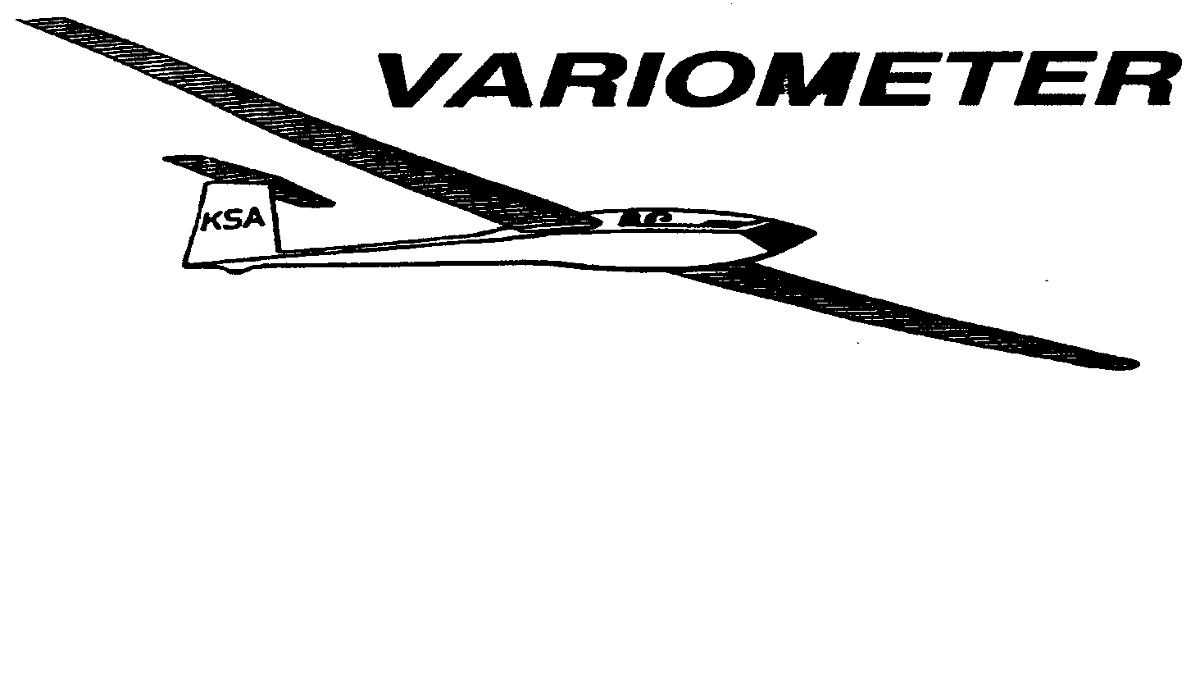

PUBLISHED TO RECORD
THE UPS AND DOWNS
OF THE
KANSAS SOARING ASSOCIATION
January 2011 Editor: Andrew Peters
PRESIDENT – ANDREW PETERS (2011-2012)
SECRETARY/TREASURER – NEALE EYLER (2011-2012)
VICE PRESIDENT EAST – BOB BLANTON (2011-2012)
VICE PRESIDENT WEST – BOB HALL (2011-2012)
TOW PLANE MANAGER – STEVE LEONARD (2011-2012)
DIRECTORS:
RAY GIRARDO (PAST PRESIDENT)
DAVE STANKO (2011-2012) SUMMER GAJEWSKI (2011-2012)
FRANK O’DONNELL (2010-2011) DAVE WOODY (2010-2011)

Notes from the President

I hope everyone enjoyed the holidays. Kinsey and I traveled to Indiana and visited with many family and friends. We drove, making this only the second time in ten years I have not flown home for a trip. But on the road, I was reminded of how much more complicated flying is versus driving. And about the time we reached Columbia, MO, I was reminded of how much faster a 172 is compared to a 4Runner!

As we kick off 2011 and I begin my term as the KSA President, I am excited about the future. We have many things to look forward to: the annual awards banquet, the annual safety meeting, the spring work day, beginning flight operations, contests, cross country, instruction, towing, etc. But all of these things require something – YOU! Without your participation, there can’t be any flying or a Kansas Soaring Association.

So, please participate. Come to the awards banquet – time is running out for you to get in your RSVP. Come to the monthly meetings. Come to the Spring Work Day. Come out to the field and fly!

Happy Landings,
AP
KSA Calendar
2011
January 1st – First Flights of the Year (Sunflower)
January 8th – Awards Banquet – Woodlawn Baptist Church
February 12th – 7:30 pm KSA Meeting at NIAR
March 12th – 7:30 pm KSA Meeting at NIAR
April 9th – 7:30 pm KSA Meeting at NIAR
May 14th – Evening KSA Cookout Meeting at Sunflower (5:30 pm)
June 11th – Evening KSA Cookout Meeting at Sunflower (5:30 pm)
July 9th – Evening KSA Cookout Meeting at Sunflower (5:30 pm)
August 13th – Evening KSA Cookout Meeting at Sunflower (5:30 pm)
September 10th – Evening KSA Cookout Meeting at Sunflower (5:30 pm)
October 8th – 7:30 pm KSA Meeting at NIAR (Elections)
November 12th – 7:30 pm KSA Meeting at NIAR
December 10th – 7:30 pm KSA Meeting at NIAR

SSA 2011 Calendars Are Available!
Neale Eyler has calendars available for $9. Get yours today!

Sunflower Seeds

January 1 2011 – Bob Hall came looking, but left before the crowd showed up. Steve Leonard, Dennis Brown, Summer Gajewski, Rich Stone, Ron Blum all showed up. Darren and Max Libby also flew in to the field. The beginnings of a mouse nest were found in the Grob, but efforts were made to remove it and prevent further development.

Comments from the Editor

Thanks to Summer, and Steve for submitting articles for the Variometer. I am going to hold onto them for future issues. Thanks also to Tony for the write up from his flight in Texas last Labor Day weekend.

This issue is shorter than most, because I wanted to get it out to you ASAP. Notice, I did include photos – so get the digital cameras dusted off and ready for this coming soaring season. And don’t forget to take some notes about your flights. Everyone has a story to share. I am always willing to help you get it out. – 3T

KSA ANNUAL AWARDS BANQUET

JANUARY 8, 2011

WOODLAWN BAPTIST CHURCH
960 S. WOODLAWN
WICHITA, KANSAS

$12.50 PER PERSON

Time: 6:00 Social
6:30 Dinner
Awards after Dinner

MENU
Fresh Salad on the Table
Beef Brisket
Potatoes
Seasonal Vegetable
Rolls
Assorted Dessert
Coffee, Tea, Water

Reservations needed. Please contact one of the following to make your reservations:
rayandginisharp@juno.com
Neale Eyler – 729-0659
Ray Girardo – 942-0638
Soaring over Llano Estacado
By Tony Condon

Ever dream of soaring like a bird? Most people have, I believe, and it was this dream that brought me to Littlefield over Labor Day 2010. When faced with the long weekend I analyzed the forecast and decided Littlefield was the place to be. I wanted to go for maximum distance and altitude and conditions looked ripe for both.

My ship, like all sailplanes, is a compromise. Designed in the 1950’s to be built at home it sacrifices performance for simplicity and low cost. The structure is aircraft quality wood with fabric covering and all told it weighs in at 600 lbs with me aboard. The compromise results in a forward run of 23 feet for every foot lost while flying at 50 mph. As a result I’ll need to stop and thermal more often and spend more time to cover the same distance, when compared to some of those sleeker sailplane designs.

I came seeking international recognition. Sailplane pilots are recognized with several levels of achievement and I was looking for Gold and Diamonds. I wanted to gain 9,800 feet (3000 meters) from my lowest point in flight for Gold Altitude and to finish my Gold Badge. Only about 2500 pilots have achieved this in the USA since the award was established in the 1930’s.

The Diamond? A 186 mile (300 kilometer) triangular flight that would have me returning to Littlefield at the end of the day. The plan was to launch from Littlefield as early as possible and drift with the wind to Hereford. From there, a turn southwest into the wind to Portales through the middle of the afternoon, the hottest part of the day, with the strongest thermals. After Portales, a quick glide back to Littlefield to finish the day.

The flight started out slow. I launched from the Littlefield Airport at 12:30 PM and started to climb in the first thermals of the day. Wind was out of the southwest a 20 mph. I was unable to climb higher than 7000 ft for the first few hours as I worked towards Hereford. It was definitely dicey flying that low as there was several times where I thought I was going to have to land. Thankfully I was able to find another thermal each time and continue the flight. Once I passed Dimmit the conditions became more typical of soaring in the Texas panhandle. I quickly climbed to 14,200 feet at about 700 feet per minute!

Now things were starting to heat up and with the extra altitude I could afford to fly faster. I quickly rounded the Hereford airport and headed towards Portales. I dove away at a blistering 75 mph. With the higher speed I lost altitude faster, but the speed allowed me to cover more ground as I battled the 20 mph headwind. As is typical with high thermals they were spaced far apart. I managed to find a good one about every 10 miles, usually after dropping down below 10,000 ft, sometimes as low as 6000. I did my best to stay above 10,000 though so that I had a good cushion and didn’t have to worry about landing.

Of course, Mother Nature had other ideas and as I neared Bovina I started to get low. I quickly sank below 10,000 feet with no indication of a thermal. As I crept below 7000 and then 6000 I really worried that my day was about to end. I was down to about 5000 feet over the large cattle lot there when I found the thermal I was looking for, and boy was it good! I rocketed to 15,000 feet at 800 feet per minute! My Gold Altitude was in the bag! I celebrated the accomplishment and kept pressing on, past Clovis and towards Portales.

By now it was getting to be about 6:00 PM. Often the soaring weather starts to weaken by this time of the day; however I could see several dust devils around. These columns of garbage, dirt, and dust are caused by strong thermals tossing skyward whatever they pass. For me they were a welcome sight, indicating that the day was still working. However I was starting to get a little low again and all of the dust devils were out of my range. I started to work around the north side of Portales as I headed towards the airport, 5 miles to the southwest. I had been low before and was not particularly worried but as always I had a few good looking fields picked out in case I needed to land.

Well the save was not to be this time. I searched all over for a thermal but none were to be found in my area so it was time to land. I found a nice looking open field and made a nice smooth landing.

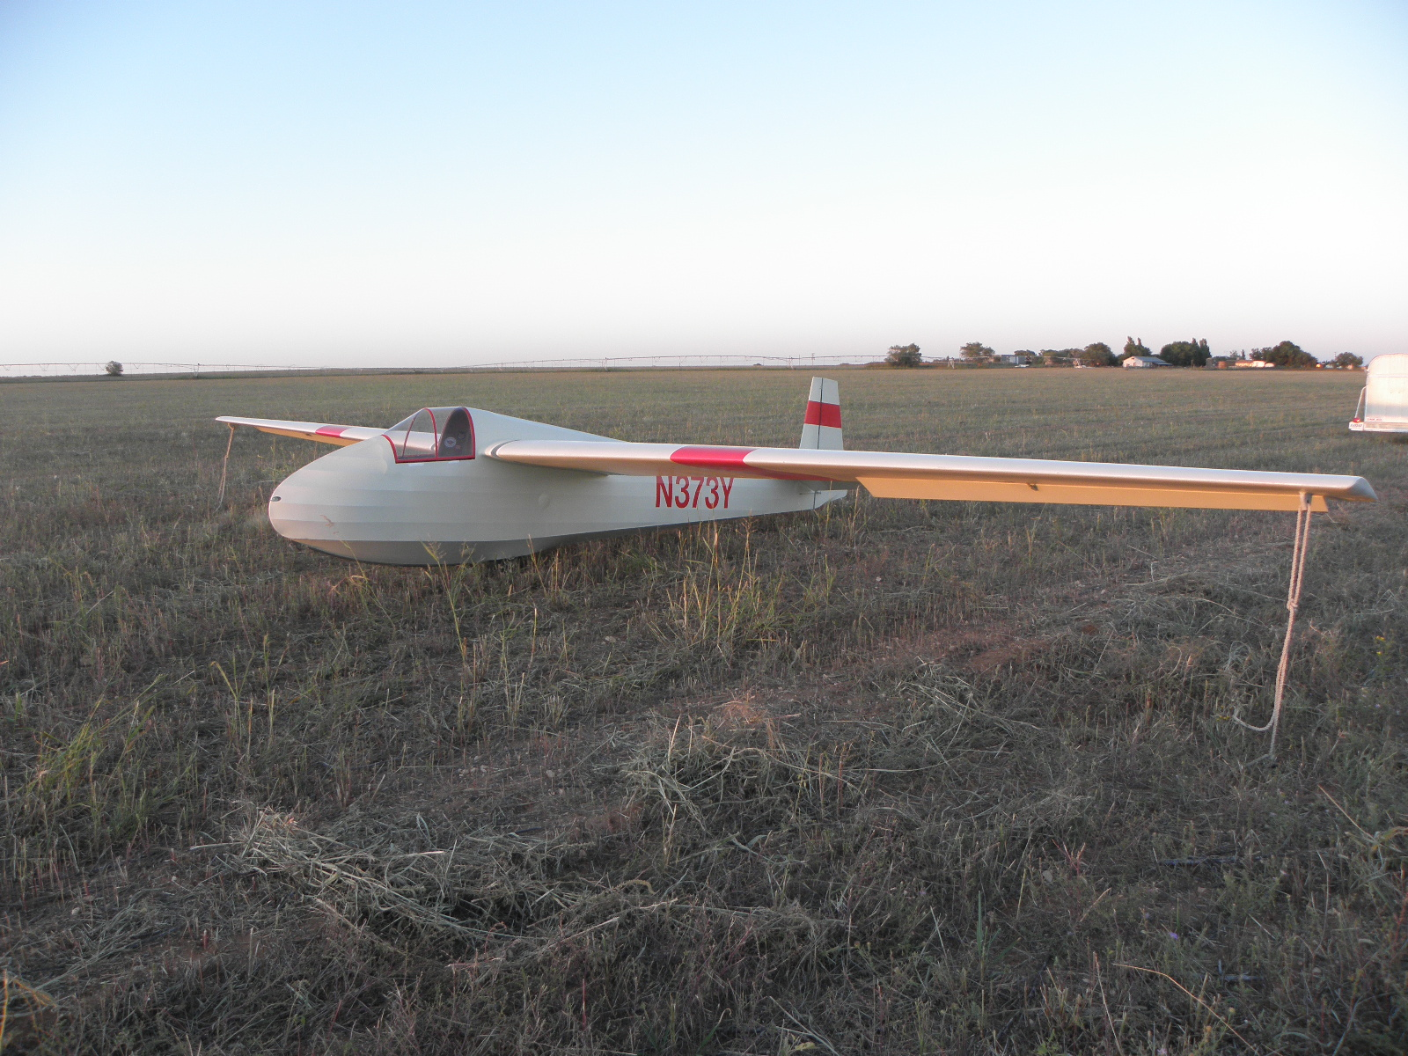

Within an hour or so my wife Leah was on the scene with trailer in tow and we soon were out of the field and ready for the trip back to Littlefield.

The flight was a great success. I had traveled 156 miles in 5 hours and 50 minutes. The flight was the highest scoring flight flown from Littlefield this year in the international online soaring contest. Most important to me was that I had managed to achieve the Gold Altitude gain and complete my Gold Badge. This made the 1200 miles of driving for the weekend completely worth it in my mind. On Labor Day Monday Leah and I enjoyed the drive back to Wichita, KS.

KSA VARIOMETER
5101 E27TH STREET N
WICHITA, KS 67220
apsoars@yahoo.com

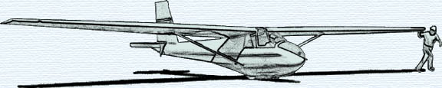

MONTHLY KSA MEETING
KSA AWARDS BANQUET
Saturday January, 2011
Social: 6:00 PM
Dinner: 6:30 PM
AT
WOODLAWN BAPTIST CHURCH
960 S. WOODLAWN
WICHITA, KANSAS

